Rochak Kunwar

Team: Low Life’s

Role: Individual Contributor – Tester

Responsibilities: Creating appropriate and effective test scenario for testing the quality of SRS produced. Collaborating with team, assisting QA and Team lead to find if there is any defect in SRS produced. Communicate to the Team Lead to receive information about the project.

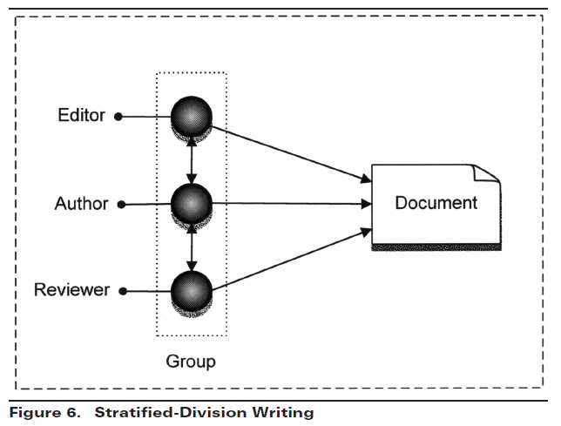Writing Strategy: Stratified-Division Writing

CW Activity: Content Creator

Document Control: Google Docs

CW Role: Testing the Documents produced to make it better and more effective

Collaborative Technologies: Microsoft Teams

Rubric:

|  |  |  |  |  |  |
| --- | --- | --- | --- | --- | --- |
|  | Exceptional 100% | Good 90% | Acceptable 70% | Developing 50% | Missing 0% |
| Unambiguous 40% | All responsibilities are unambiguously described | It is clear what is to be done on the SRS | All responsibilities are described to some degree of detail but ambiguity exists | Part of the role is described | It is unclear what is to be done on the SRS |
| Contribution 60% | By following this plan, more than a fair share of the work will be done | A critical and important part of the process will be accomplished | You will "pull your weight" | It is unclear that the fair share of work will be done | It appears that most of the work will be done by others |